**Online Car Dealer System**

**Professor**

Masoud Milani

**Team Members**

Johann Henao

Rogelio Alonso

Yang Zhang

Ariel Cambas

Table of Contents

1. Introduction 3

2. Current system 3

3. Proposed system 4

3.1 Overview 4

3.2 Functional requirements 6

3.3 Nonfunctional requirements 6

3.4 Constraints (“Pseudo requirements”) 7

3.5 System models 8

3.5.1 Scenarios 8

3.5.2 Use case model 12

3.5.3 Object model 19

3.5.4 Dynamic models 26

# 1. Introduction

Our client “Sunshine Car Dealer Inc.” is in the business of selling cars. They want to extend their business model to include an online car sales system that they wish to call “Sunshine Online Car Dealer Inc.”. Sunshine Car Dealer understands that having a web site and an ecommerce solution will be extremely important to continue to stay competitive in the car selling industry. As part of their ecommerce business model they want to provide a different buying experience to their customers in the comfort of their home. In addition they wish to cut down on personnel expenses so being able to offload some part of their sales to an online shopping experience will help them achieve that objective. Sunshine Car Dealer also wishes to be able to consolidate their inventory from all of their car selling agencies and an online solution will help them with that as well.

# 2. Current system

Sunshine Car Dealer Inc. does not have an online system. Currently all car sales transactions are performed at the different car dealer agencies. Sunshine Car Dealer Inc. wants to include an online ecommerce system as part of their business model.

# 3. Proposed system

## 3.1 Overview

The user interface for the Sunshine Online Car Dealer system will be completely web browser based. The system will consist of an Apache Web server running in a Linux OS with a MySQL database server. Different development technologies will be used to implement this solution such as PHP, java script, java servlets, java jsps to name a few. The development collaboration of choice will be github. Below is a high level overview of the proposed online car dealer system:





## 3.2 Functional requirements

1- The system shall have a function to search cars from the available car inventory. The search criteria will be through selectable values, no free format input from the user.

2 – The system shall have a function to route a user to register or login.

3 - The system shall display the search result (from requirement 1) with the basic car information.

4 - The system shall allow the user to request a more detailed car information per car within the search results from functional requirement 3, which will return a page with pictures of the car, basic car information and additional notes.

5 - The system shall have a function to purchase a car. To purchase a car, a user must be registered and logged in.

6 – The system shall allow a user to register and/or login.

7 – The system shall allow a user to reset the login password in case it is forgotten.

8 – The system shall display an order confirmation after the user submits the payment information.

9 - The system shall allow the user to update its profile information.

10 – The system shall provide and administration portal.

11 – The system shall allow the creation of additional administrators.

12 – The system shall allow the administrator to view/edit/delete all registered users.

13 – The system shall allow the administrator to view/edit/delete the car inventory.

14 – The system shall allow the administrator to generate a sales report in a valid date range.

## 3.3 Nonfunctional requirements

* + Usability

The Sunshine Online Car Dealer System will be available at all times and accessible from any computer connected to the internet with a browser.

* + Reliability

The system will be a secure reliable source to make a vehicle purchase.

The Sunshine Online Car Dealer System will not have an invalid input as all the input option will be provided for their selection.

The Sunshine Online Car Dealer System will only provide for sale whatever is available in its inventory.

* + Performance

Out of scope but we will aim to implement a system that has a competitive performance with a response time per page of less than 8 seconds.

* + Supportability

Very portable since every device (i.e.: Smartphone or Tablet) with a browser will be able to access the Sunshine Online Car Dealer System .

The Sunshine Online Car Dealer System has been designed with Entity, Boundary and Control objects making the system more adaptable to maintainability, changes and support.

## 3.4 Constraints (“Pseudo requirements”)

* + The systems interface must be any web browser.
  + Sunshine Online Car Dealer System must contain a MySQL database with at least one user as Administrator.
  + It must assign a session to every user accessing a domain web page.
  + It has to be capable to support three types of user (Guest, Customer & Admin)
  + The Sunshine Online Car Dealer System has to sell cars with minimal human supervision.
  + The system sells 1 car at a time per user transaction.

## 3.5 System models



### 3.5.1 Scenarios

**Scenario 1: Login to Sunshine Online Car Dealer System**

Bob wants to buy a car from the web site of Sunshine Car Dealer. He goes to the home page of Sunshine Online Car Dealer System and chooses to log in. He enters his username and password, then click login button. The screen displays the home page with his status as logged in.

**Scenario 2: Buy a new car**

Bob found his dream car on the web site of Sunshine Car Dealer. He decides to buy it. After logging in, he selects his dream car and click “check out” button. Then he enters his billing and shipping address, credit card information, and click “purchase” button. After a short time of processing, he sees an order confirmation page with a delivery date.

**Scenario 3: Add more pictures of a car**

Peter is one of the administrators of Sunshine Online Car Dealer System. He received some detailed information about a Honda CRV 2012 which is in the car inventory. In order to provide the customers a better view of this car, he decides to add the new information.

He logs in to the system to the admin home page. Then he click “Edit” button of this CRV. The system displays the fields can be edited; and he click the “Details” field and starts to edit. After he is done editing, he clicks the “update” button to save his changes. Then the information of this CRV is updated.

**Scenario 4: Create a new admin account**

Sue is hired as an administrator of Sunshine Online Car Dealer System yesterday. Peter is creating her a new admin account.

He first logs into the system on the admin home page. Then select “Add Admin” button. The system displays the required fields that need to be filled. After he enters all the information needed including the assigned username and password for Sue, he clicks the “Create” button. Now Sue has her own admin account.

**Scenario 5: Change shipping address**

Johann receives a phone call from Ms. Yang stating that she’s unable to change her Shipping Address in the Online Car Dealer System. Johann logs into the system and selects the “Edit User Profile” function.

Johann search for Ms. Yang User Profile and updates the Shipping Address with the new one provided by Ms. Yang. He advises her to refresh her browser page and check for the correctness of the new address.

Ms. Yang is displayed with her User Profile with the correct new Shipping Address.

**Scenario 6: Add cars to the system for sale**

Every week Johann is presented with a list of new cars ready to be sold in the Online Car Dealer System. He logs into the system and select the “Add a Car” function.

Johann enters the information of the new vehicle and creates a folder for the vehicle pictures. He then proceeds to copies the each pictures in the vehicle picture folder.

After submitting all the vehicles details a confirmation page is displayed stating that a new vehicle has been added to the system.

**Scenario 7: Delete a user**

Johann is notified of a fraudulent user trying to steal from the company with false information. He logs into the system and select the “Remove User” function.

Johann search for the falsified user account and press the remove button. The system asks Johann to reconfirm if this is indeed what he intends to do.

Johann acknowledges and the user account is deleted from the system.

**Scenario 8: Search for a car**

Yang opens Internet Explorer on her home computer and goes to the Sunshine Online Car Dealer website home page. Yang is interested in new Toyota 4 runners so she clicks on the ‘Make’ dropdown list in the ‘search cars’ section and selects ‘Toyota’. Next she clicks on the ‘Model’ dropdown list and selects 4-runner. Yang continues to select ‘New’ on the ‘Condition’ dropdown list. Yang then clicks on the submit search button. The web browser returns a page with a list of all the new Toyota 4-runners that are available for purchase.

**Scenario 9: Register**

Roger is a guest user who is interested on possibly purchasing a car at the Sunshine Online Car Dealer System. Sunshine Online Car Dealer requires users to register in order to be able to purchase cars. Roger opens up a browser and goes to the Sunshine Online Car Dealer home page. There Roger clicks on the Login/Register button. Roger is taken to the Login/Register page and there he clicks on ‘Register’. Roger is presented with a web form that displays all of the fields that are required to be filled in order to register and obtain a user account. Once all fields are completed Roger clicks on the ‘Submit Registration’ request button. The system checks that the e-mail does not exist on another user’s record in the database. If the email does not exist the system creates a record on the database and takes Roger back to the home page with a Logged in status.

**Scenario 10: Generate a sales report**

Ariel is an administrator user for Sunshine Online Car Dealer. Ariel is asked by one of the car dealer managers to print out a sales report for current month. Ariel opens up a web browser and goes to the Sunshine Online Car Dealer website home page. There Ariel clicks on login/register. At the login/register page Ariel enters his administrator login credentials and clicks on login. The web server receives the request and checks the login credentials against the database server. After a successful authentication the web server responds by redirecting Ariel to the Administrator home page. There Ariel clicks on the “Generate Reports” button. Ariel is taken to the “Reports” page and there he clicks on “Generate Sales Reports”. Ariel is taken to the “Sales Reports” web page and he enters the desired date range and finally clicks on “Generate Report”. The system responds back with a web page with the sales report information for the date range selected.

**Scenario 11: Reset forgotten password**

Johann is a regular registered user in the Sunshine Online Car Dealer website. Johann has forgotten his password so he goes to the Sunshine Online Car Dealer website home page and clicks on Login/Register. At the Login/Register page, Johann clicks on the “Forgot Password” link. The systems display to Johann the Forgot Password web page where he can enter his email user id which is the email he registered with and then clicks “Submit Request” button. The system checks the user id against the records in the database and if the user id exists the system updates the user record with a random password and sends out an email to the address in the database with the random password. Johann checks his email and sees an email from Sunshine Online Car Dealer Inc. with the new password information. Johann proceeds to login with his new password and updates his password once logged in by clicking on “Update Profile” on the upper right hand corner of the page.

### 3.5.2 Use case model

#### 3.5.2.1 Use case diagram

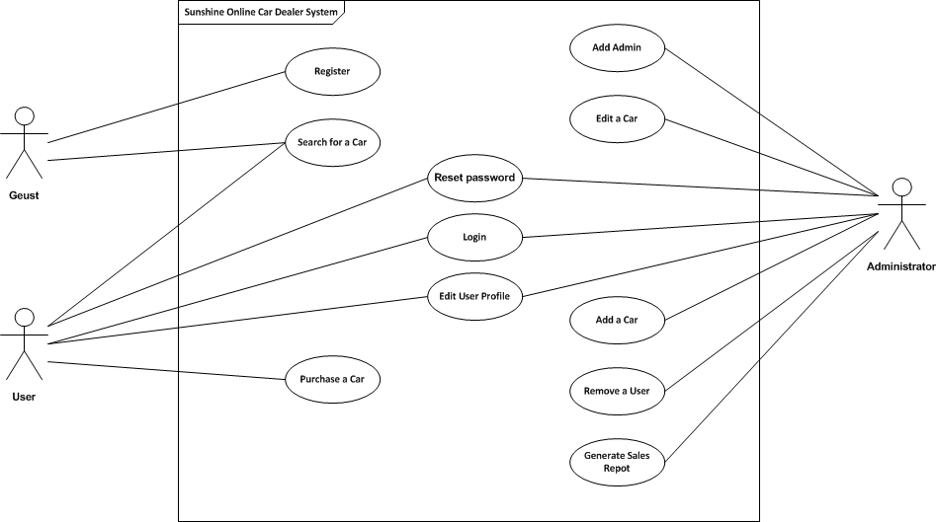

#### 3.5.2.2 Use Cases

**Use Case 1**

* Name: Login
* Actor: User/Admin
* Entry Condition:
  + User/Admin must be at the login web page of Sunshine Online Car Dealer System.
  + User/Admin has a valid username and password.
* Event Flow:
  + User/Admin input username and password into the Login web page.
  + Sunshine Online Car Dealer System match username/password entered with list of stored users/admin.
  + Sunshine Online Car Dealer System logs User/Admin into the system.
  + User/Admin are redirected to home/index web page or into the requested page showing a logged in status.
* Exit Condition: User/Admin is logged into Sunshine Online Car Dealer System.
* Exceptions:
  + Cancel
  + “Wrong Username/Password”
  + “No connectivity”

**Use Case 2**

* Name: Purchase A Car
* Actor: User
* Entry Condition:
  + User must be at a web page of Sunshine Online Car Dealer System displaying a list of cars.
  + User must be logged in.
* Event Flow:
  + User selects car to be purchased.
  + Sunshine Online Car Dealer System displays the car details including price.
  + User selects Purchase option.
  + User enters the credit card information to purchase the selected car.
  + Sunshine Online Car Dealer System shows a confirmation web page with transaction details and delivery date.
* Exit Condition: User purchased a car.
* Exceptions:
  + Cancel
  + Invalid Credit Card Information
  + Sold to another faster customer

**Use Case 3**

* Name: Edit A Car
* Actor: Admin
* Entry Condition:
  + Logged in as admin
  + On the page with the “Edit a Car” function
* Event Flow:
  + Admin choose to do “Edit a Car”
  + Edit the information of the car in the inventory
  + Submit to update the car’s information
* Exit Condition: Admin updated a car’s information.
* Exceptions:
  + Cancel
  + Repeated Unique values

**Use Case 4**

* Name: Add Admin
* Actor: Admin
* Entry Condition:
  + Logged in as admin
  + On the page with the “Add Admin” function
* Event Flow:
  + Admin choose to do the “Add Admin”
  + Enter the information of the new admin that needs to be added
  + Submit it to create the new admin
* Exit Condition: A new admin user is created in the system.
* Exceptions:
  + Cancel
  + “Username already exists”

**Use Case 5**

* Name: Edit User Profile
* Actor: Admin/User
* Entry Condition:
  + Logged in
  + On the page with the “Edit User Profile” function
* Event Flow:
  + Admin/User choose to edit the User Profile
  + Edit the information
  + Submit to update the user’s information
* Exit Condition: User’s profile information is updated
* Exceptions:
  + Cancel
  + Repeated Unique values

**Use Case 6**

* Name: Add A Car
* Actor: Admin
* Entry Condition:
  + Logged in as admin
  + On the page with the “Add A Car” function
* Event Flow:
  + Admin selects the “Add A Car” function
  + Enter the information of the new car that needs to be added
  + Submit it to create the new car
* Exit Condition: A new car is added in the system.
* Exceptions:
  + Cancel
  + Repeated Unique values

**Use Case 7**

* Name: Remove a User
* Actor: Admin
* Entry Condition:
  + Logged in as admin
  + On the page of a list of users with the “Remove User” function
* Event Flow:
  + Admin selects the user needs to be removed
  + Select the “remove” function
  + System asks to confirm to do the remove
  + Admin confirm to remove the user
* Exit Condition: The selected user is removed from the system.
* Exceptions:
  + Cancel

**Use Case 8**

* Name: Search for a Car
* Actor: Guest/User
* Entry Condition:
  + On the home page of Sunshine Online Car Dealer System
* Event Flow:
  + Guest/User select desired car from the detail fields
  + Guest/User submit to search
  + Sunshine Online Car Dealer System displays a list of cars
* Exit Condition: Guest/User has a page displaying a list of cars.
* Exceptions:
  + “No cars found.”

**Use Case 9**

* Name: Register
* Actor: User
* Entry Condition:
  + User must be at the registration web page of Sunshine Online Car Dealer System.
  + User has an email account and residence address.
* Event Flow:
  + User input personal information (First name, last name, email, username, password, billing address, shipping address).
  + User submits the information to register.
  + Sunshine Online Car Dealer System checks if username or email is not taken, and creates a new user account.
  + User is redirected to home page showing a logged in status.
* Exit Condition: User has an account in Sunshine Online Car Dealer System.
* Exceptions:
  + Cancel

**Use Case 10**

* Name: Generate Sales Report
* Actor: Admin
* Entry Condition:
  + Logged in as admin
  + On the admin home page with the “Generate Sales Report” function
* Event Flow:
  + Admin selects the date range of the desired report.
  + Select the “generate” function
  + System displays the sales report in the date range.
* Exit Condition: The system displays the sales report.
* Exceptions:
  + Cancel

**Use Case 11**

* Name: Reset forgotten password
* Actor: User/Admin
* Entry Condition:
  + User must be at the log in web page of Sunshine Online Car Dealer System.
  + User must be registered before.
* Event Flow:
  + User selects the “Forgot password” function.
  + User/Admin enters his/her username.
  + Sunshine Online Car Dealer System checks if the username is valid.
  + Then the system sent an email with a random password for his/her account.
  + User/Admin login with this random password and goes to his/her profile to change password.
* Exit Condition: User can login to Sunshine Online Car Dealer System with the reset password.
* Exceptions:
  + Cancel

### 3.5.3 Object model

Object Models are object-related diagrams of pages and pages of source code, and represent an overall organization of object types and their relationships. Although they don’t have a fine level of detail and can lack precision, they are easy to understand and provide a more appropriate “big picture” of the solution.

The purpose of Object Modeling is to represent objects from the “client world” as programming classes and objects. Even though these objects have a name similar to a concept from the problem domain, classes and objects are defined in their source code to behave and represent a related object from the “real world” that is needed in the system. Moreover, Object Models describes how this classes will work together to supply the client desired functionality by the type of link between them.

The Sunshine Online Car System will contain the following classes:

1. **Online Car System**
2. **User**
3. **Admin User**
4. **Regular User**
5. **Inventory**
6. **Car**
7. **Picture**
8. **Credit Card**
9. **Transaction**

**Online Car System Class**

The **Online Car System Class** will be our system principal class. It will be responsible for providing searches to users and guest or allow guests to register in the scheme. The **Online Car System Class** is the entry point to the car dealer since it will handle authentication, either login in or out of the system.

The principal attributes are **Inventory** and **User**. The **Online Car System Class** will contain one Inventory object (we will discuss this object further on) and many **User** objects. 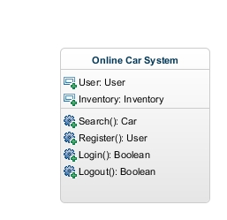

**User Class**

The **User** class will model general user objects such as: Name, Middle and Last Name, Shipping and Billing Address, Username, Password, Email and Log Status. This class will serve as a super class to the **Admin User** and **Regular User** class.

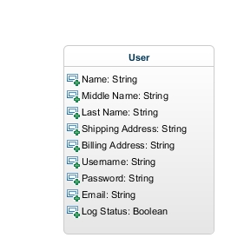

**Admin User**

The Admin User class inherits from the User class; however, its functionalities are different. It is in this class scope to:

* Add/edit either a Car or a Regular User object
* Add/edit/remove another Admin User objects.

Another Admin User responsibility is to confirm or ship cars from inventory.

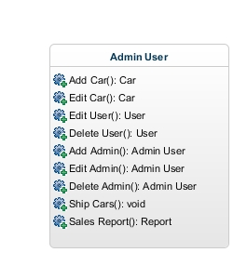

**Regular User**

The Regular User class will be distinctive because it will contain an attribute of class Credit Card. It will be constrained that at least one Credit Card is associated with the Regular User, but there will be no maximum in the quantity of this object for the Regular User class. The User will have full access and control over his/her Credit Card objects, being able to add, edit or remove them at any time.

The Regular User profile will consist in those attributes inherited from the User class except for the username. The Regular User profile will another feature left for the user to update. Regular User can purchase Car with Credit Card and there is no limit about the maximum Car objects a regular User can purchased. The more the better will be for the business.

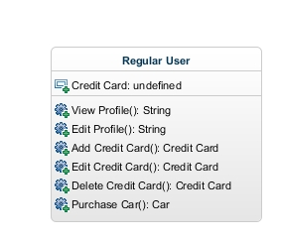

**Inventory Class**

The Inventory class will behave as car warehouse; hence, will contain attributes of type Car objects. Also, for programming benefits it will contain an integer field with the available quantity of vehicles for sale.

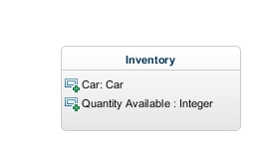

The relation between class Inventory and Car will be from one to many. The Inventory class allows many Cars object and again there is no limit on the maximum number of Car object within the inventory class.

**Car Class**

The Car class has attributes as follows: VIN (Vehicle Identification Number), Make-Model, Year, Price, Mileage, Color and Color Details, Condition and Comments, Pictures and Car Status. The VIN number will be unique for each car, Price value can’t be zero or negative and the Comments attribute will contain any specific luxury or especial feature within the car. This class will include a maximum of five pictures represented by class Picture. Finally, the Car Status attribute will provide the current status of the Car class (e.g. SOLD, AVAILABE).

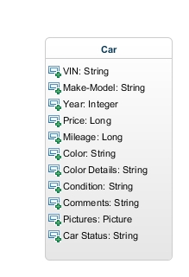

**Picture Class**

The functionality of this class is to model an image of the Car. This will be done by providing the address in hard drive where this picture is located.

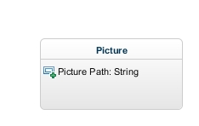

**Credit Card Class**

The Credit Card class attributes are the name of the person in that Credit Card class, the Credit Card number, expiration date, security code and the type. This class will always be an attribute of the Regular User class and never instantiated from other classes.

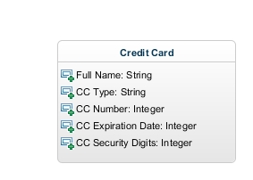

**Transaction Class**

The responsibility of the transaction class is to define the type of transaction. So far in this implementation we only purchase cars but other transaction types can be implemented here.

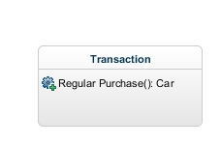

The Regular Purchase method is to be called by a Regular User class and defined to sale one object of type Car to the user. It is expected to estimate time of delivery and to change the Car Status property in the Car class, as well as charging the price of the object Car into the Regular User Credit Card object.

#### Class diagrams

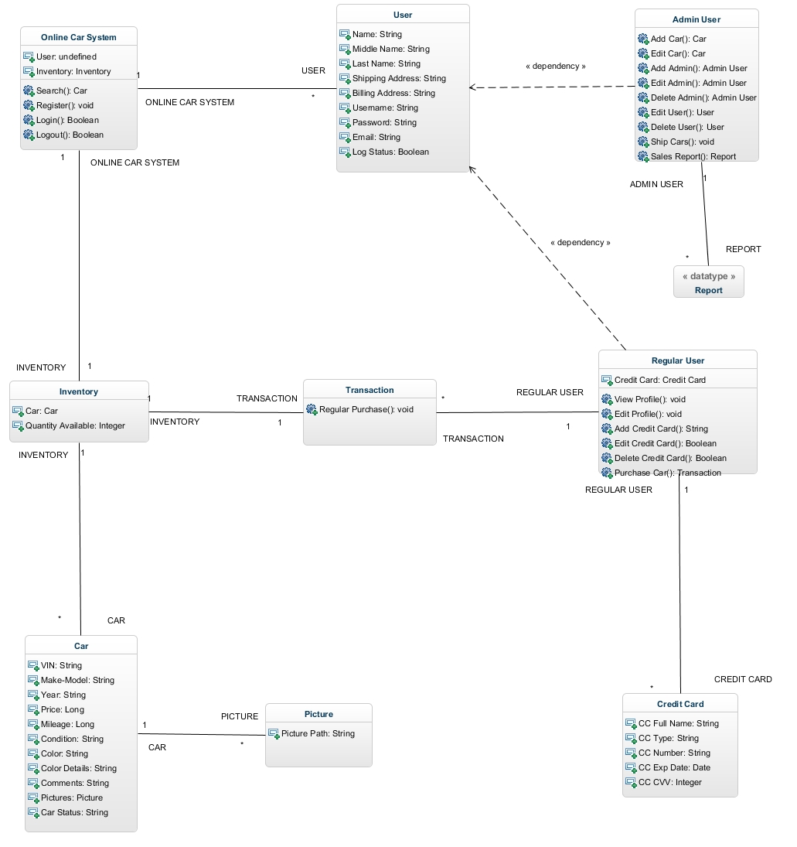

### 3.5.4 Dynamic models

**Sequence Diagram 1**

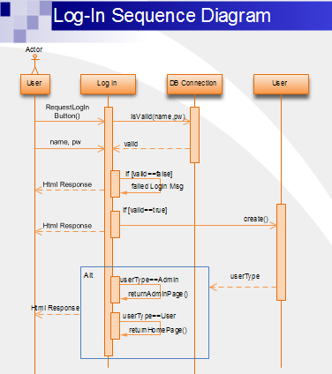

**Sequence Diagram 2**

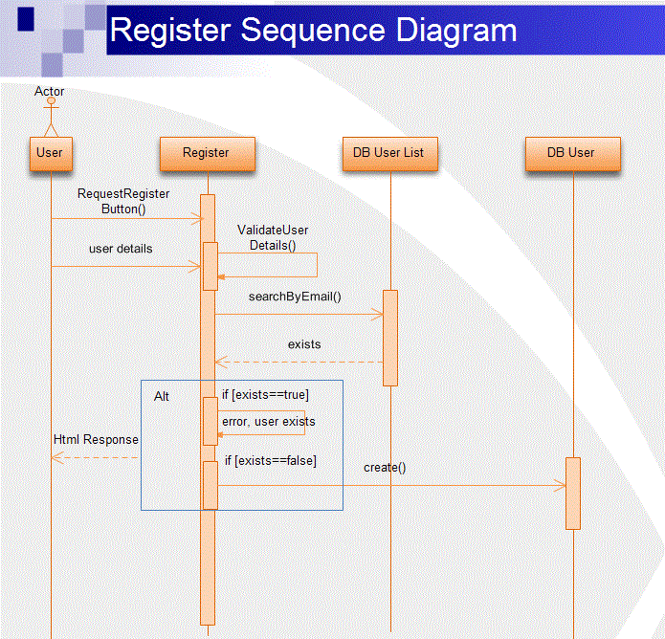

**Sequence Diagram 3**

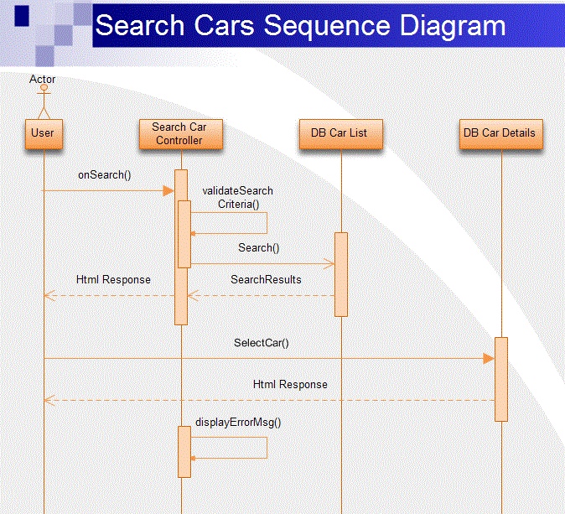

**Sequence Diagram 4**

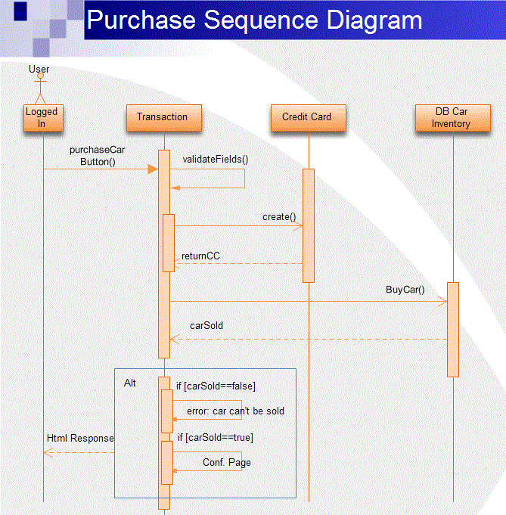

**Sequence Diagram 5**

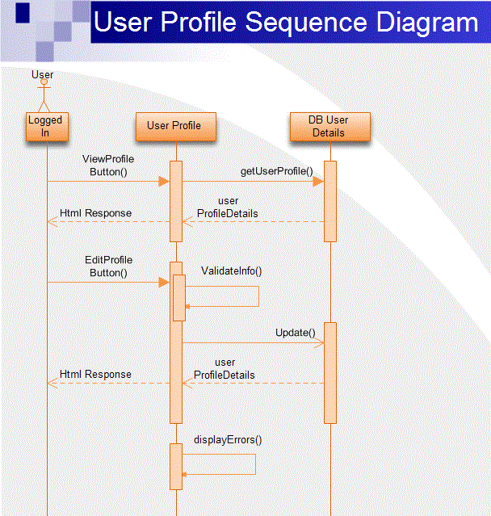

**Sequence Diagram 6**

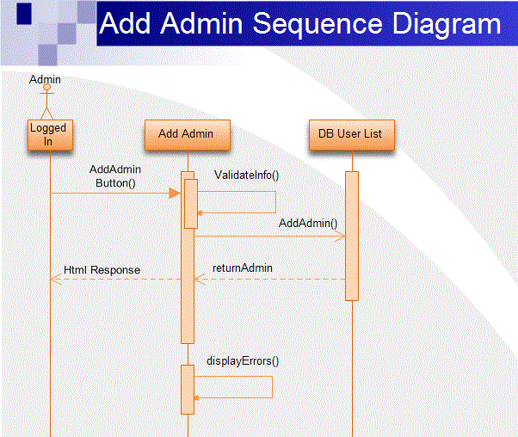

**Sequence Diagram 7**

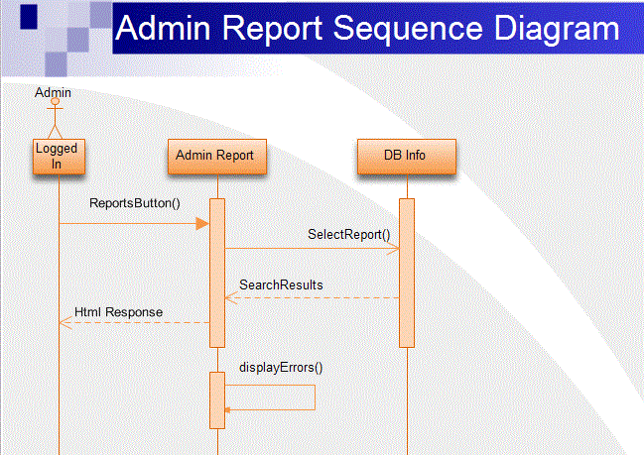

**Sequence Diagram 8**

